Garmin Coding Exercise

Please complete the below question and submit a scan, picture, attachment or GitHub link to [Jessica.Zlab@garmin.com](mailto:Jessica.Zlab@garmin.com).

Question #1 Instructions

1. Write code that searches the below tree and finds the node named “FindMe”.
2. Your program should print out the name of each node it visits.
3. Your program should stop searching when it finds the target node.
4. A Node is defined as:

class Node

{

public string Name { get; set; }

public List<Node> Children { get; set; }

}

1. The tree has this structure:  
   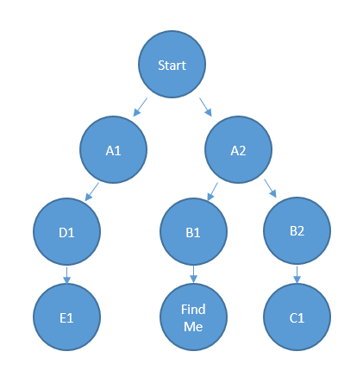
2. Your program can be in any language as long as it is syntactically correct (and compiles/parses).